PRINT.PHP

* Printing for ASSESSMENT FORM - ok ung preview, naka right ung alignment ng mga Subjects, pero pagiiprint na nagcecenter sila. We tried different printers ganun pa din. Panu kaya un? Eto sample pag ipprint na.. notice nakacenter ung subects.

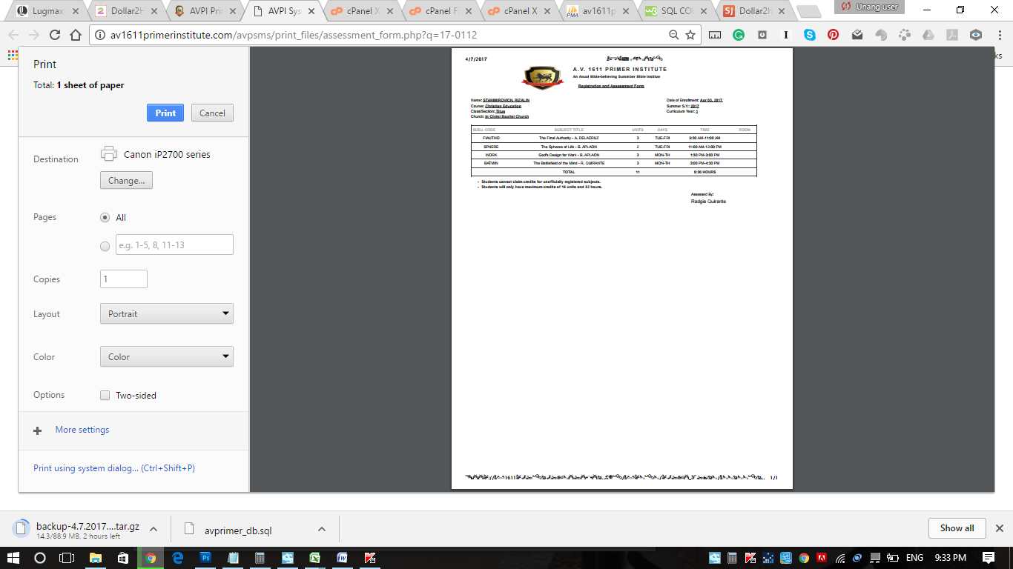

With regards narin sa Assessment Form printing, paki ayos daw ung logo para hindi magstretch ang itsura. :)

* GRADE SHEETS - URGENT din po ito sana umabot before April 24.

SUBJECTS.PHP

* binalik ko ung original na codes na hindi pa kasama ung NUMBER OF STUDENTS kasi nageerror xia - nagkaproblema sa pagshshow ung subjects ng 2017, magshow xia tapus biglang mawawala. Nung binalik ko ung lumang code nag ok naman. pero hindi parin nagshoshow ung subjects ng 2017 pag 2017 ang unang naselect sa dropdown. need pang iclick ung ALL para magshow sila. (As shown below, selected ang 2017 pero walang nagshhow na subjects intially.)

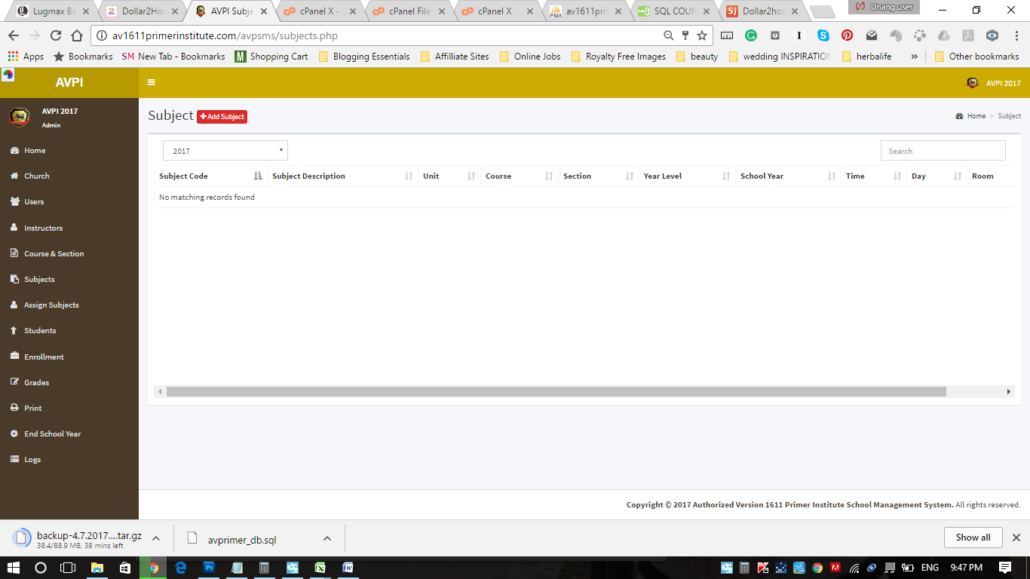

* padd narin dito NUMBER of STUDENTs if possible.

INSTRUCTORS.PHP

* May button below the drop down that reflects the value selected on the dropdown menu. Parang dito oh...

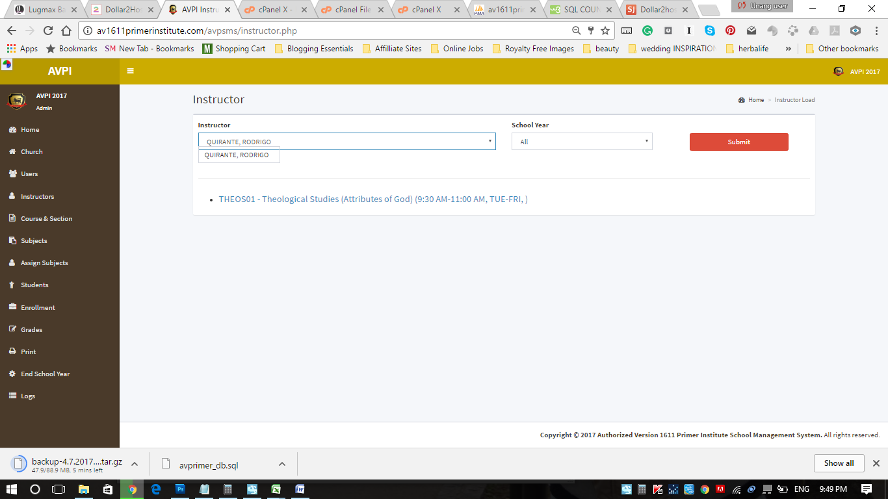

STUDENTS.PHP / ENROLLMENT.PHP

* As requested the DELETE function on STUDENT.PHP doesn't actually delete the record on the database. It just deactivates the record via the column 'account_status' (with value 1 or 0). That is fine. But when we look at the ENROLLMENT.PHP, the deactivated record still appears. I think hindi lang naset ng ayos ang condition dito.

HINDI KO ALAM KUNG SAN ITO PWEDENG ILAGAY pero urgent din.

* total number of students per year.